Open 10Mile TT Keswick – L1010
Promoted for and on behalf of Cycling Time Trials under their rules and regulations
Saturday 1st May First rider off: 14:05hrs
Event organiser: Kenneth Brown Timekeeper: Mrs Tracey Moore
33 Chaucer Road, Workington, Cumbria, CA14 4HQ Assistant: Mr Tim Houghton
Tel 07921334158 email kennethbrown81@sky.com

Event HQ- Embelton Village Hall, Embleton, Cumbria, CA13 9XU. Parking is limited please park curiously. Please see note on Page 2 for parking. The HQ is approximately 3.7 mile from the start and will be open from around 13:00. HQ is only to be used for toilet facilities all Social distance signage to be strictly followed.
Course details
START in the lay-by at the Bassenthwaite Lake side of the A66 road at the eastern end of the dual carriageway in line with the white mark 5 yards west of the easterly end of the tarmac footpath section. Proceed in a south-easterly direction along the A66 to encircle the Roundabout at the junction with the A591 Keswick/Bothell road (5.3 miles).Retrace along the A66 to FINISH at the white mark at grate in the roadside immediately east of a farm gateway approximately 0.2 miles before the Thornthwaite junction and 0.8 mile short of the start (10 MILES).
The following Local Regulations have been approved by the national Committee in accordance with Regulation 38. Any breaches may lead to disciplinary action being taken.
Local regulation No. 5: In all events, competitors prior to starting are not permitted to ride past the finish timekeeper during the duration of the event.
Local regulation No. 6: Any competitor making a ‘U’ turn in the vicinity of the start or finish will be disqualified from the event.
Local regulation No. 10: Warming up on the course is not permitted during the duration of the event
Local regulation No. 15: Riders must keep to the left hand side of the road except when overtaking. Failure to comply with the above may lead to disqualification.
Local Reg No 17 On the L1010, competitors must not access the Start Lay-By via the carriageway break and ride West bound on the East bound carriageway. This will lead to disqualification from the event.
In Addittion to the above
Riders must give their number at the finish and elsewhere on the course if requested.
Riders must NOT STAND in the road at the start or finish. (This constitutes obstruction and is a breach of Regulations).
Riders must NOT ride with their heads down.
CTT Regulation 14 Competitors Machine – Rear Lights No competitor shall be permitted to start either a Type A or Type B event unless such competitor has affixed to the rear of their machine a working rear red light, either flashing or constant, that is illuminated and in a position that is clearly visible to other road users.
Helmets: All competitors under the age of 18 and/or JUNIORS must wear a HELMET of HARD/SOFT SHELL construction that conforms to a recognised Standard (See Regulation 15). The CTT state that helmets are Mandatory for all riders under the age of 18. Cycling Time Trials strongly recommends ALL competitors to wear such a helmet.

AWARDS- one rider one prize (except team)
 | 1st | 2nd |  |  | 1st
Overall | £40 | £30 |  | Ladies | £40
Vet 40 | £30 | £20 |  | Ladies Vet | £30
Vet 50 | £30 |  |  | ESP | £30
Vet 60 | £30 |  |  | Jun/Juv | £30
Vet 70 | £30
Team of 3 | £30

Disposable numbers will be used, No times will be available at the event, all prizes will be via BACS or Paypal

Parking.
Please note Parking at the HQ is limited. Please do not park on the road outside the HQ and leave this available as a drop off area for people to sign ON/OFF prior to parking permanently elsewhere. Parking is available near the start at Beck Wythop, Thornthwaite road and also the road alongside Dubwath Meadows Nature Reserve.
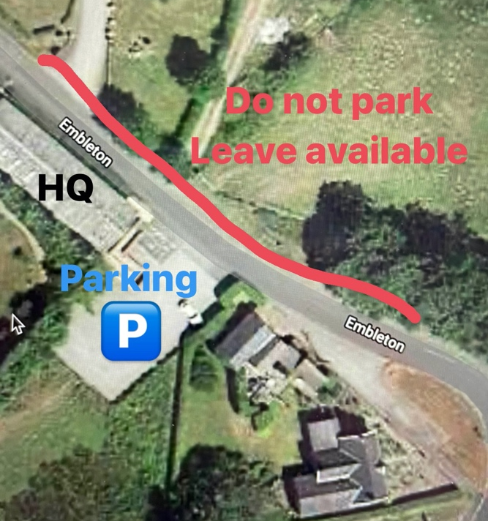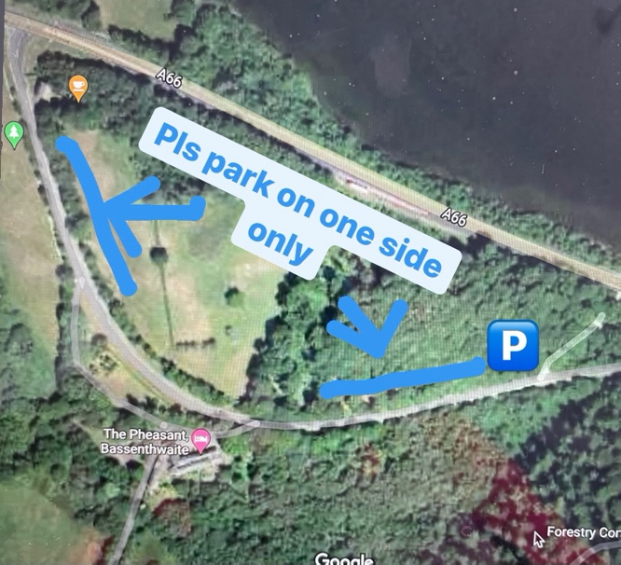
HQ – Parking Old road to Pheasant inn (dubwath). Only park one side and at either end of the road, not by Pheasant inn
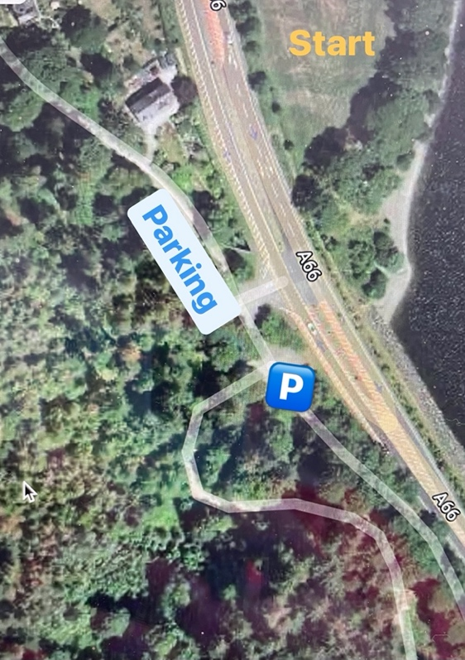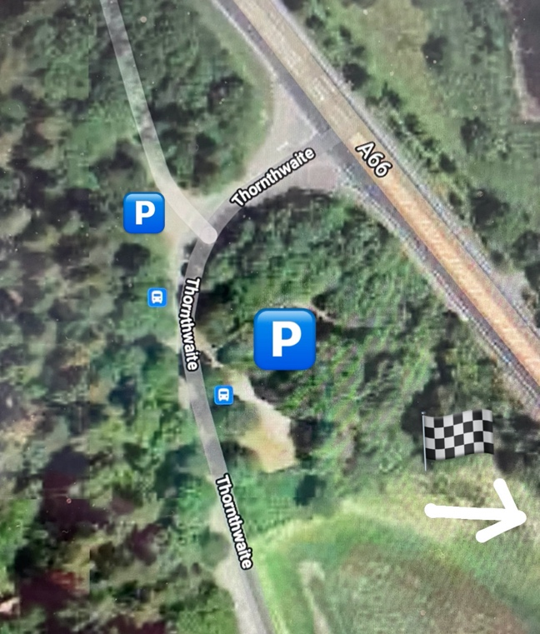
Parking Near Start (beck Wythop) And finish (Thornthwaite rd). Please take note of Reg’s (5,6,10 & 17)

Have a Fast and Safe Ride
Thanks
Ken

